

**User Manual**

**For**

**Digital Filing System (*e-nothi*)**

***Table of contents***

**SL Title Page No.**

1. Login 3

2. Dashboard 3

3. File Filter 4

4. Upload Letter 4

5. Upload Unstructured Letter 5

6. Upload meeting Minute 5

7. Search File 6

8. Advanced Search 6

9. Register New User 7

10. Manage Roles 7

11. Attachment 7

12. Reset Password 8

1. 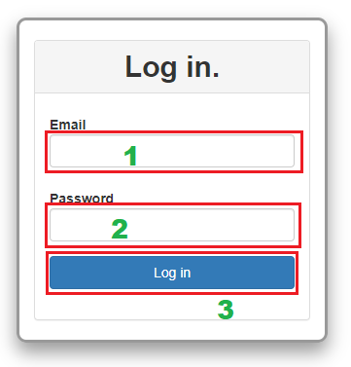**Login:** Use your registered email and password then hit the Login button to get access into the application.
2. 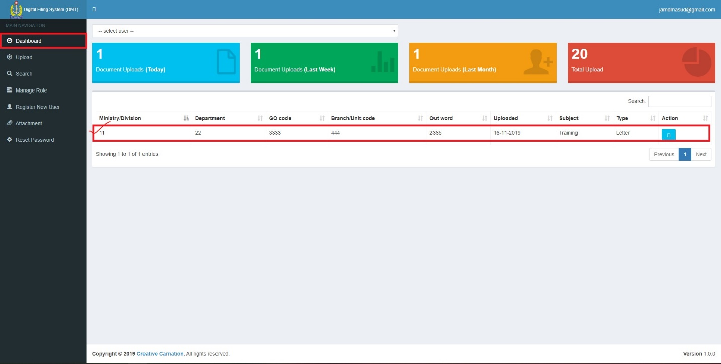**Dashboard:** After login this dashboard will be appearing and navigation menu will be shown based on user roles.
3. 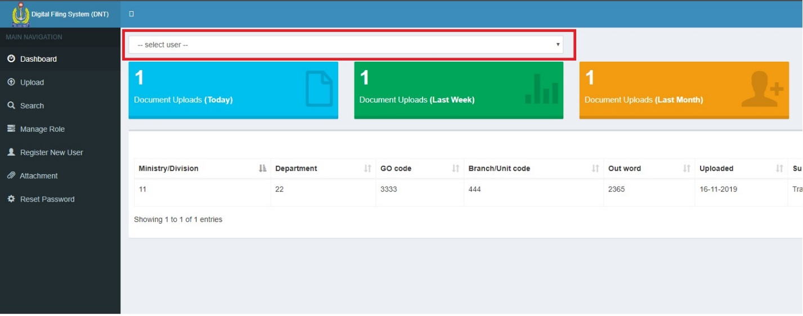**File filter:** Dashboard user can filter document by uploaded user dropdown.
4. **Upload letter:** To upload letter select upload menu and following steps:-
   * + 1. Select letter switch.
       2. Enter “letter number” if there is meeting minute reference, then check minute year and fill up all boxes.
       3. Type letter subject.
       4. Write some keywords (keyword acts like tag, you can write multiple keyword by separating semicolon (;)).
       5. Select letter date.
       6. Select files by clicking on the select file button.
       7. Hit submit button if everything is OK or press Reset button to reset the form.

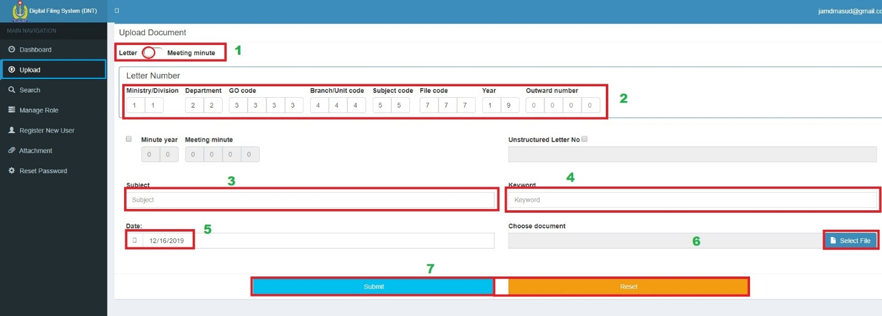

1. **Upload Unstructured Letter:** To upload unstructured letter select the upload menu and following steps:
2. Enter letter number if there is meeting minute reference, then check minute year and fill up all box.
3. Type letter subject.
4. Write some keywords (keyword acts like tag, you can write multiple keyword by separating semicolon (;)).
5. Select letter date.
6. Select files by clicking on the select file button.
7. 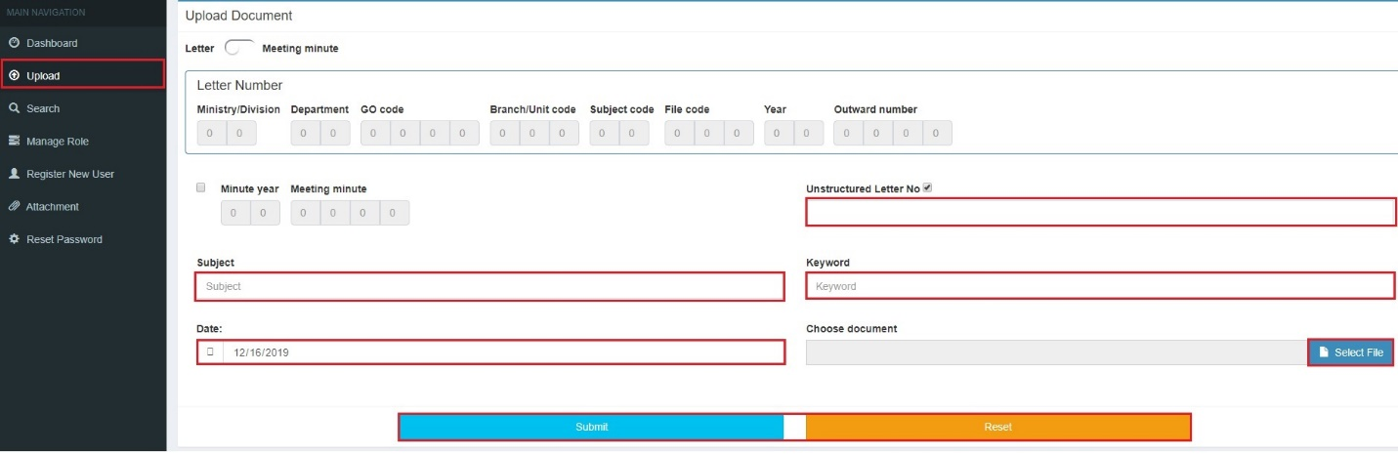Hit submit button if everything is OK or press Reset button to reset the form.
8. **Upload meeting minute:** To upload meeting minute select upload menu and following steps:
9. Select meeting minute switch.
10. Enter letter number.
11. Type letter subject.
12. Write some keywords (keyword acts like tag, you can write multiple keyword by separating semicolon (;)).
13. Select letter date.
14. Select files by clicking on the select file button
15. 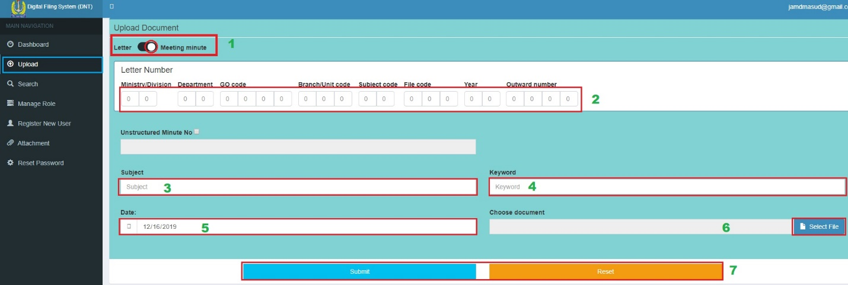Hit submit button if everything is OK or press Reset button to reset the form.
16. **Search file:** User can search file (nothi) by letter number, keyword, subject or unstructured letter number by following ways.

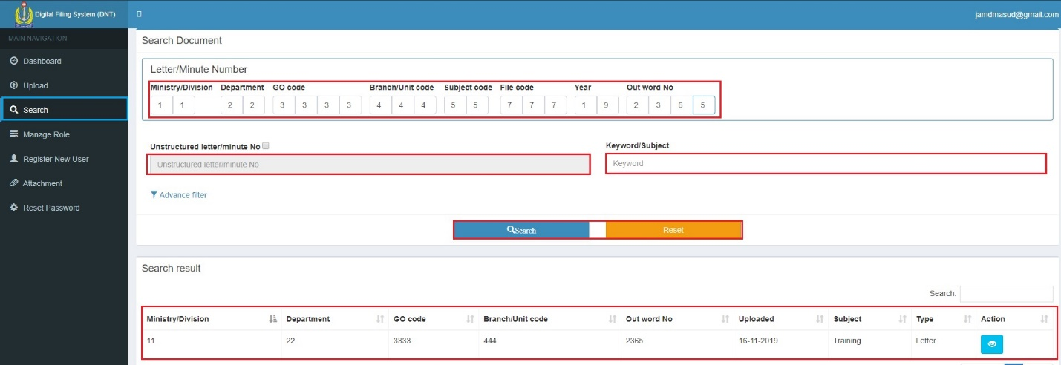

1. 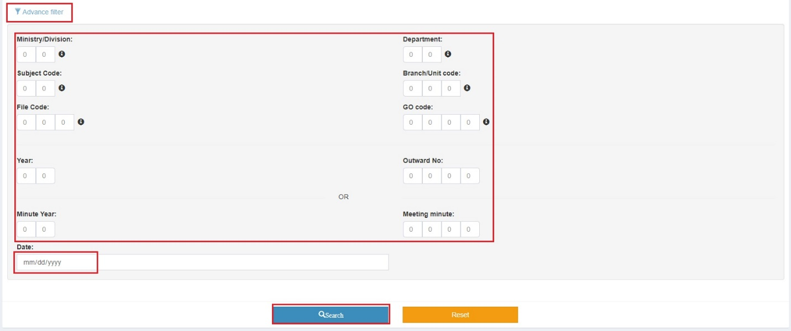**Advanced search:** A user can search in a more advanced manner. To do that, click on the Advance filter button and use one or more fields to search expected file. User can view his/her desired code clicking on the information icon (i).
2. 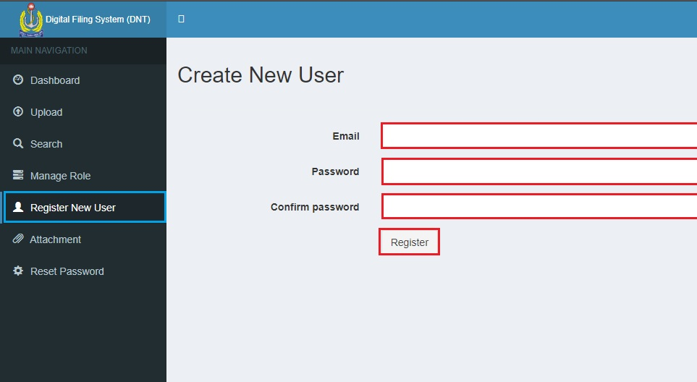**Register new user:** To register a new user, click “Register New User” menu from the navigation menu bar, Enter user’s email and password then “Register” button.
3. **Manage Role:** Role based authentication and authorization is implemented here, so admin need to set or manage user roles and a user must have dashboard access role. If a user is removed from all roles then he/she can’t login the application at all.

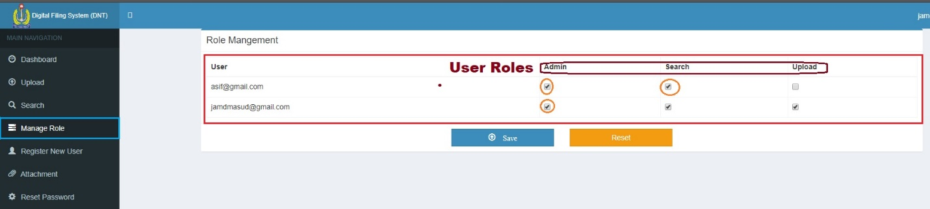

1. 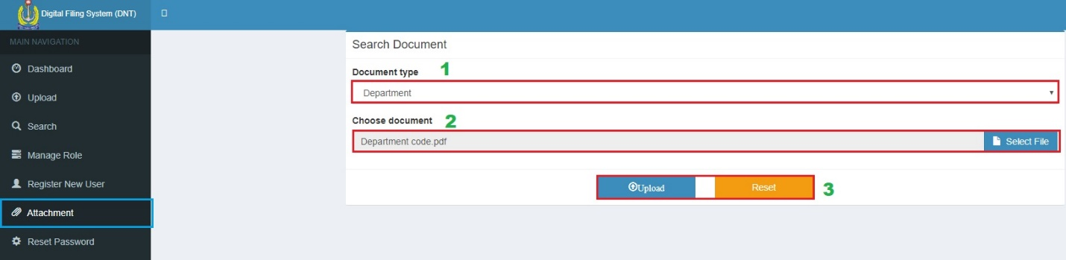**Attachment:** Upload some documents that contain information of “letter number” and which are shown in advanced search page of “i” button.
2. **Reset password:** A user can reset his/her password from the “Reset Password” navigation menu, but admin can reset any user’s password. If the user is not admin, he/she will type his/her email, password and password again for confirmation then hit the reset button. Admin can use any email to reset password.

